**TEAM TRANSITION REPORT**

Vanessa S. Akwa

David Dela Nuworkpor

Glenn Bartels Odoom

Emmanuel Agyei

Papa Yaw Boampong

Innocent Farai Chikwanda

Keren Grant

Tendai Machaya Terrence

Paa Kwesi Jnr. Thompson

Adjowa Serwaa A. Asamoah

David Babafemi Oluwadomilola

Business Administration Department, Ashesi University

BUSA162_H: Foundations of Design and Entrepreneurship

Sihaam Mohammed, Sub staff: Eugenia Anyawoe

Cohort H

29th November 2022.

**PROBLEM-SOLUTION FIT**

**Problem:** Inadequate infrastructure in the agricultural sector.

From the interviews and research we conducted, we discovered that most small-scale farmers in Ghana do not have access to infrastructure, especially storage facilities and this results in the loss of about 50% of the produce they harvest. This high rate of post-harvest losses is especially common among farmers who produce perishable goods such as vegetables. Therefore, we decided to focus on small-scale vegetable farmers in Ghana, starting with those closest to us in Berekusu.

**Solution:** Aya seeks to serve as a ready and reliable link between vegetable small-scale farmers in Berekusu and the ready market. With the help of a fully functional ERP system, our company, AYA, is developing a small-scale farmer trading system to reduce post-harvest losses and help optimize the value transfer between small-scale farmers and commercial vegetable buyers. We do this with our aggregated system of farming used to amass large amounts of produce and mentorship program meant to educate small-scale farmers on efficient farming practices.

Ideally, we will remove the burden of searching for buyers from farmers while aiding the farm to the best of their abilities through mentorship. This system will give the small-scale farmers we work with access to ready buyers and the support they need to curb postharvest loses and increase their overall production power.

**BUSINESS MODEL CANVAS AND CASHFLOWS**

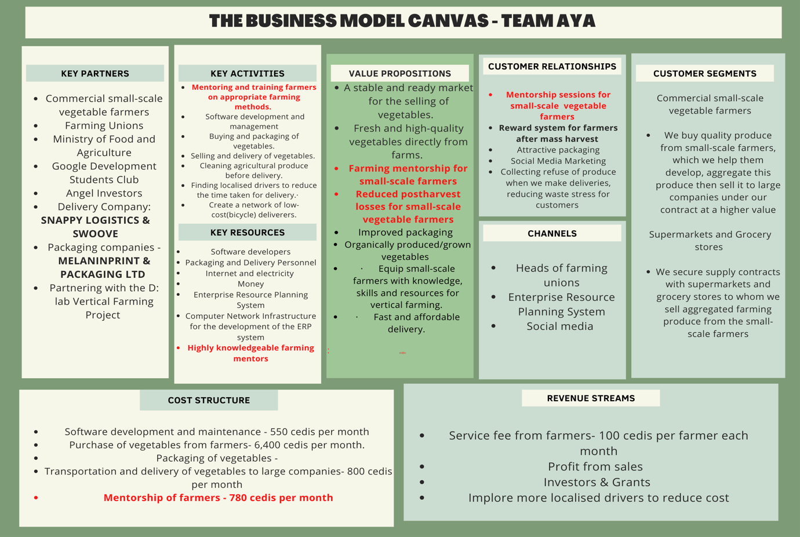

**Cashflow statement**

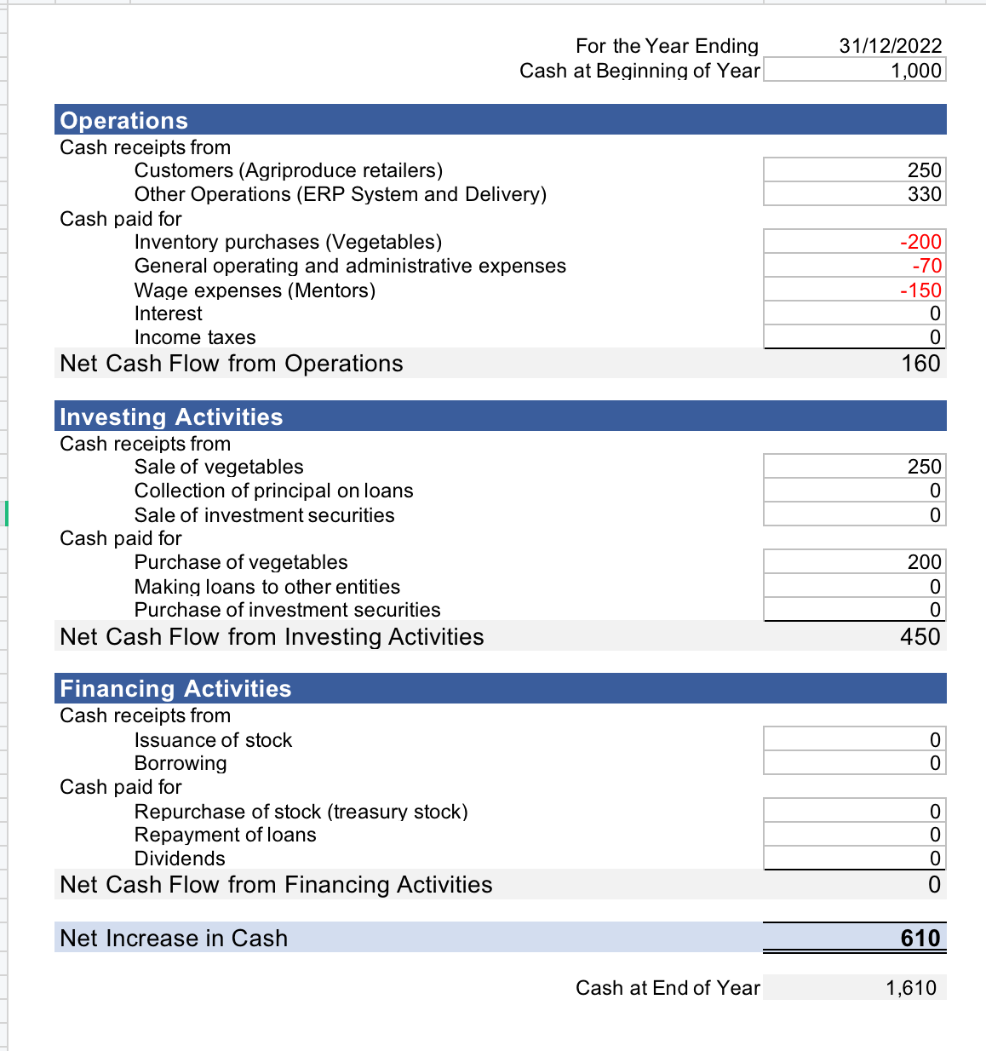

**Our business model is viable** for two main reasons. First, we can make enough revenue to offset the cost we incur and keep the business running with the possibility of even scaling. Second, the solution Aya is providing is one that will have the same positive impact in the future as it has now. Our business goal is to reduce the rate of post-harvest losses small-scale farmers experience. Due to this group's low production power and inability to afford efficient storage facilities, the value we are offering will always be needed.

We planned on generating revenue from the service fee that we would charge our farmers for our mentorship program and ready access to the market. We decided charge 5 percent per farmer for every bulk sale made. This makes sense because our fee would be significantly less than the amount of money they lose due to post-harvest losses thus farmers would be willing to work with us. The profit from the delivery and sale of aggregated farm produce to supermarkets and grocery stores is another source of revenue for our team. We also innovated the revenue streams of our business model to include localised drivers. The purpose of this innovation is to reduce the cost of transporting vegetables to buyers. **These systematic measures we have put in place will enable us to make enough profit to offset the cost we incur from the purchase of vegetables, our mentorship programme and the maintenance of our ERP system.**

**BMC UPDATES**

We updated the **value proposition block of our BMC** by including the sale of purely organically grown vegetables in our business. From our research, we found that some of our secondary customers desire organic produce. As a result of this, we implemented the trade of purely organic produce to fully capture the attention of those buyers. We intend to acquire purely organic produce by mentoring farmers and conducting regular checks on how they farm and manage their vegetables.

We also included fast and affordable delivery services to our **key activities**. From interactions with our customers, they mentioned that they would not be interested in a company that offers a negative delivery experience hence we decided to enhance our delivery system. Our delivery system has been structured in such a way that when you place your order and follow the other necessary procedures, you can get access to your product within that same day. In cases where we lack the quantity of product you desire; we would inform you and communicate with you the best possible date of delivery. This helps reduce the risk of food spoilage and ensures that customers are happy and can access their produce in good shape.

For our **key partners**, we made updates by deciding to partner with the Ashesi D-lab Vertical Farmers project. We plan to outsource to them the role of equipping and mentoring our small-scale farmers with vertical farming techniques to help them increase productivity. We partnered with the vertical farmer's project as it is a sure way to reach out to more of our farmers and because of the innovative means of farming this group provides.

We also updated the customer **channel** block of our business model. We decided to implore bicycle and motorcycle riders in the Berekusu township to deliver our vegetables to buyers. The purpose of this innovation is to cut down delivery time and cost. The delivery service would employ youth in Berekuso to handle delivery for our company on commission and enable us to reach all the customers that our vehicle delivery system cannot.

**MVP LAUNCH AND COVID-ERA**

Although employing online user interactions was not as effective as in-person meetings would have been, remote user interactions proved to be very convenient. This is because most of our interviewees and customers, such as potential angel investors, delivery companies and agriproduce retailers, are based in Accra. We could not meet them as often as we would have liked. Therefore, employing the use of remote interactions was convenient. We learnt that adaptation to new situations is very important. We also learnt the importance of being proactive enough to develop feasible solutions to minor problems. Where in-person interactions could not be possible, we had to learn as a team to employ the use of online polls, phone calls and zoom meetings to reach our respondents.

In-person interactions such as meetings with small-scale farmers were very effective since these meetings allowed us to witness intangible ethnographic data that could only have been gained from being present during research (the reactions of our interviewees first-hand). In-person testing was also very convenient because it allowed us to reach a larger group of people with whom we could test our assumptions and receive instant feedback from.

**PROMOTIONAL ACTIVITIES**

**Feedback from Users**

Value proposition – Customers were satisfied with our service because we delivered vegetables that were directly from the farm. Our customers were also satisfied with the timely and cost-effective delivery service we offered. The small-scale farmers we worked with were also satisfied with our high level of honesty in our dealings with them. However, our buyers were dissatisfied with the packaging and presentation of our vegetables.

Customer segments – Our buyers agreed to keep buying from us if we meet the standard for quality and packaging. Our secondary customers agreed to continue buying from us, especially if we improve the packaging of the vegetables we sold. From the interviews we conducted with 10 small-scale farmers, we discovered that they will be willing to work with us if our terms of condition are favourable. The small-scale farmers also agreed to keep working with us if we offer a good price for their produce.

Cost structure – We decided to rely on the purchase of vegetables directly from farms throughout the lifespan of our business. This is because purchasing vegetables directly from farms is cheaper, and this will help lower the costs we incur. We also decided to include proper packaging of vegetables as part of the services we offer. Although this will slightly increase the costs we incur, it will help us acquire more customers and retain existing ones. We also decided to implore bicycle and motorcycle riders in the Berekusu township to deliver our vegetables to buyers. The purpose of this innovation is to cut down delivery time and cost.

Revenue Stream – In addition to the funds we hope to solicit from angel investors and the Ashesi Venture Incubator, we decided to apply for government funds to help keep our business running. This is a great source of revenue, particularly because we have no obligation to repay it. Receiving funds from the government will help our company's reputation and perhaps draw in additional investors.

**Lessons Learned**

From our launch, we noticed that our business is likely to make more losses than profit if we do not put strategies in place. To track our profit, the sales team undertook market research to aid us to decide on appropriate prices for our produce. The financial team oversees producing comprehensive reports on our sales over a given period. They do so by subtracting our production costs from our revenue to determine our profits and losses. The Operations Team oversees using the ERP system to manage our financial transactions. In the event of any changes in our business operations, we will still have all the relevant data we need to make necessary changes or to ensure that our profit margin increases.

Before and during our launch, we discovered that our buyers were dissatisfied with the packaging of our vegetables, and they would only keep buying from us if we provided attractive packaging. We, therefore, included the attractive packaging of the vegetables to our promotional activities. Since we operate in an existing market, we learnt that we had to develop strategies to beat our competitors and gain a share of the market. This led to the decision to include vigorous social media marketing, outdoor marketing and content creation (making of explainer videos) to our MVP and promotional activities. To beat our competitors, it was also necessary for us to offer reduced prices to our buyers. We decided to do this by offering them vegetables directly from farms since this would be cheaper.

**FDE OUTCOME AND TRANSITION**

Retire – As a team, we have decided to discard the project and move on. However, any team member(s) who is still interested in the idea can come back to form a new team to complete the project with. This decision was reached due to the complex, time-consuming and costly demands of the business. Retiring the business would also require less paper and legal work than transferring it to another entity.

**Post FDE Activities**

As a team we will;

* Sell off all assets acquired during the operation of the business.
* Inform our customers (small-scale vegetable farmers and agriproduce retailers) of our decision to discontinue the business.
* Settle all financial obligations and deliver customers' pending orders.
* Acquire legal documents that allow any member interested in picking the business in the future to do so.
* Team members who choose to retire will sign off all rights to the business.

**Potential Challenges**

If one team member takes up the business and drives it to success, there is a possibility for other team members to try to claim ownership of the business again. This challenge could be avoided by ensuring that the necessary legal procedures are carried out to transfer full ownership of the business to any team member(s) who is interested in carrying on with the business. This will give him or her legal ownership of the business and prevent any conflicts in the future.

**Required Paperwork**

We will write a report to the FDE department of Ashesi University with details of our business, our journey through FDE, our decision to end the venture and our reasons for the decision. We will also attach the required forms with our signatures confirming our decision to abandon the business.

**Prospects**

We strongly believe that even though we have decided to abandon the business, one or more team members, though not all, may develop an interest in restarting the business in the future. We believe that if this does happen, these team members will develop the venture into a successful one.